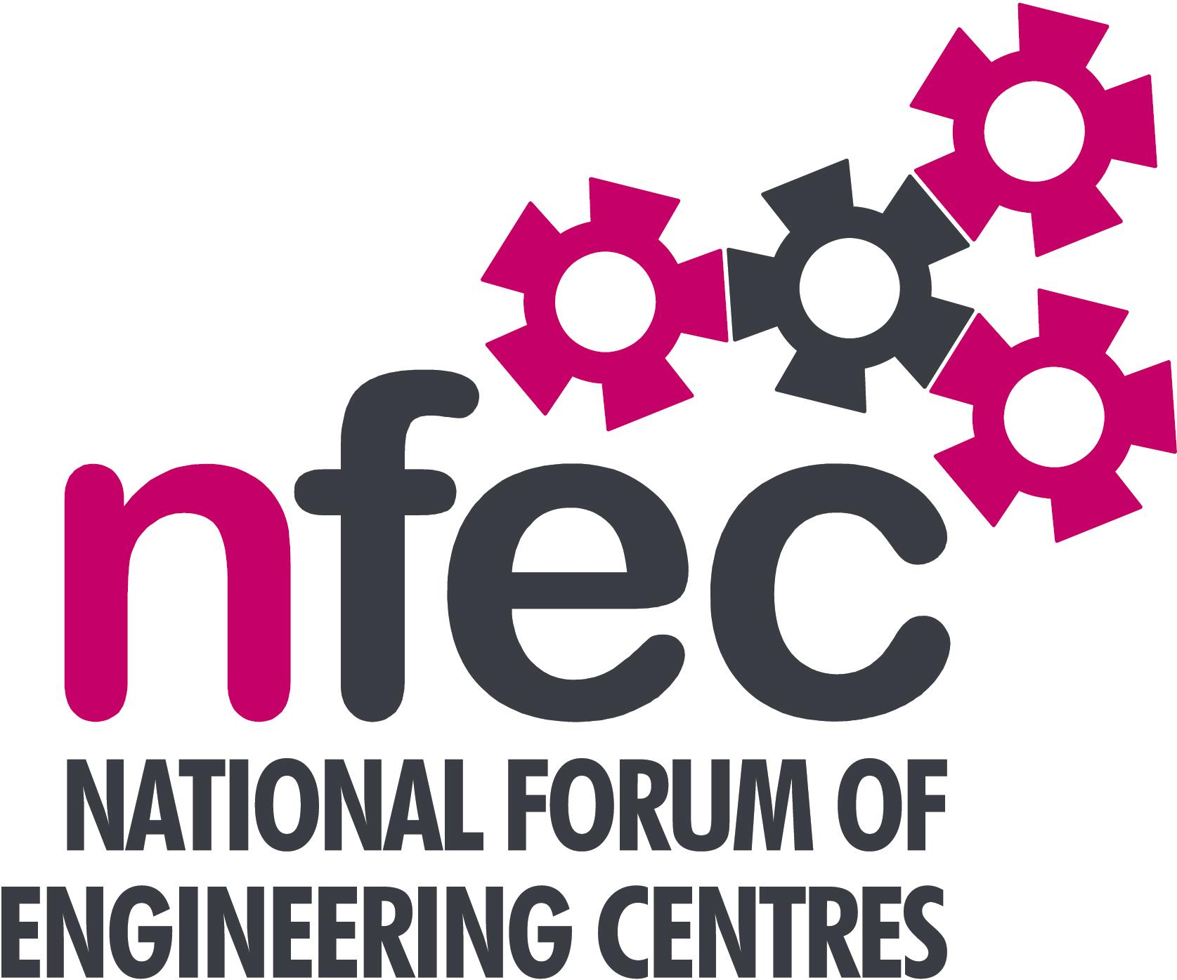
NFEC Autumn 2017 Midlands Regional Seminar

Host: Shrewsbury College

Friday 20th October 2017, 10.15am – 15.00pm (Coffee from 10.00am)
Venue: Shrewsbury College, London Road, Shrewsbury SY2 6PR
Telephone Number: 01743 342342

Programme

- Welcome and Introduction to the Seminar | Kevin Whitehouse (NFEC Midlands Regional Coordinator)  Andrew Lee – Shrewsbury College | 10.15
- Feedback from Apprentices on the Food and Drink Trailblazer programme  - T levels – dissemination and discussion of latest released information  - Qualifications and Awarding Bodies – Current developments and general issues.  - Current matters of concern relating to quality, content, structure, management and delivery of programmes of training and education in Engineering (not included on Agenda) - an opportunity for open discussion with a focus to distill key issues and plans for addressing them.  Lunch and Demonstrations by Exhibitors  Tour of facilities including the recently installed Industry 4.0 FMS system  - Plenary session – Issues to note and agreed actions for NFEC | Two apprentices from Tulip Foods  Bob Millington and Kevin Whitehouse  All Delegates  Pearson - David Lee  OCR – Martin Webber  C&G – Simon Yorke  All delegates / Kevin Whitehouse  Andy Lee / Babak and Sameer from Festo  All Delegates/Kevin Whitehouse | 10.20  10.50  11.30  12.00  13.30  14.30
- Date, Place and Topics for next Seminar  Close  Entry is free to this seminar for members or to non-members present for a first attendance.There will be a charge for non members after this. A light buffet lunch will be provided and you will be able to see/discuss demonstrations of the latest available equipment and facilities for the delivery of learning in Engineering. | All Delegates/Kevin Whitehouse  To book your place: Email: admin@nfec.org.uk  Phone: 07759 901229 | 14.45

